

**IBM NAAN MUDHALVAN**

**(INTERNET OF THINGS)**

**SMART PARKING ( PHASE 5 )**

**TEAM MEMBERS:**

**NAMES:** S.POOJA – 511321104067

V.NANDHINI DEVI – 511321104061

S.SAI APARNAA – 511321104082

R.S.RESHMA MOL – 511321104079

**DEPT:** COMPUTER SCIENCE AND ENGINEERING

**MOBILE APP DEVELOPMENT:**

Developing a mobile app for smart parking with IoT integration is an exciting project that can greatly enhance parking efficiency and convenience. Here's a high-level overview of the steps and considerations involved in creating such an app:

1. **Conceptualization and Planning:**
   * Define the scope and objectives of the app.
   * Identify your target audience and understand their needs.
   * Research existing smart parking solutions and identify unique features your app can offer.
   * Decide on the platforms you want to develop the app for (iOS, Android, or both).
2. **IoT Infrastructure:**
   * Choose IoT devices for parking spot monitoring, such as sensors or cameras.
   * Decide on a communication protocol (e.g., MQTT, HTTP, CoAP) for data transmission from IoT devices to the app.
   * Set up the necessary backend infrastructure to collect, process, and store IoT data.
3. **Backend Development:**
   * Develop a server-side application to manage and analyze data from IoT devices.
   * Implement a database to store parking spot availability and user data.
   * Ensure data security and privacy, as you'll be dealing with sensitive information.
4. **Mobile App Development:**
   * Choose the technology stack for mobile app development (e.g., native, hybrid, cross-platform).
   * Develop the user interface (UI) for the app, including a map interface that displays parking availability.
   * Implement user authentication and registration.
   * Integrate with the IoT infrastructure to fetch real-time parking spot data.
   * Develop features like in-app payments, booking, and navigation to the parking spot.
   * Implement push notifications to alert users of available spots or expiring reservations.
   * Ensure an intuitive and user-friendly design.
5. **User Authentication and Payment Integration:**
   * Implement secure user authentication, possibly using OAuth or other authentication providers.
   * Integrate payment gateways to allow users to pay for parking within the app.
6. **Location-Based Services:**
   * Use GPS and mapping APIs (Google Maps, Mapbox) to help users find available parking spots and navigate to them.
7. **Real-Time Data Updates:**
   * Set up a mechanism to provide real-time updates on parking spot availability and pricing.
8. **User Feedback and Support:**
   * Include features for users to provide feedback and contact support if they encounter issues.
9. **Testing and Quality Assurance:**
   * Rigorously test the app to ensure it works smoothly on various devices and under different network conditions.
10. **Deployment and Marketing:**
    * Deploy the app to app stores (Google Play Store, Apple App Store).
    * Develop a marketing strategy to promote the app to potential users.
11. **Maintenance and Updates:**
    * Continuously monitor and maintain the IoT infrastructure and backend services.
    * Regularly update the app to fix bugs, improve performance, and add new features.
12. **Compliance and Regulations:**
    * Ensure that your app complies with local regulations and data protection laws, as handling sensitive user data is involved.
13. **Data Analytics:**
    * Implement data analytics to gain insights into user behavior and parking spot usage, which can inform future enhancements.

**RASPBERRY PI INTEGRATION:**

Integrating a Raspberry Pi into an IoT (Internet of Things) smart parking system is a practical and cost-effective way to monitor and manage parking spaces. Here are the basic steps to set up Raspberry Pi integration for an IoT smart parking solution:

1. **Hardware Components**:
   * **Raspberry Pi**: Choose a Raspberry Pi model suitable for your needs. The Raspberry Pi 4 or newer is recommended due to its better processing power and connectivity options.
   * **Camera Module**: To capture images or video of parking spaces.
   * **Sensors**: Ultrasonic or infrared sensors to detect the presence of vehicles in parking spaces.
   * **Internet Connectivity**: Wi-Fi or Ethernet for the Raspberry Pi to connect to the internet.
   * **Power Supply**: Ensure a reliable power source for the Raspberry Pi.
   * **Enclosure**: Protect the Raspberry Pi and components from environmental factors.
2. **Software Components**:
   * **Raspberry Pi OS**: Install the Raspberry Pi OS (Raspbian) on the Raspberry Pi.
   * **Python or Node.js**: Choose a programming language for writing your IoT application. Python is popular for Raspberry Pi projects, but Node.js can also be used.
   * **IoT Platform**: Select an IoT platform (e.g., AWS IoT, Azure IoT, Google Cloud IoT, or an open-source platform like MQTT or Home Assistant) to manage data, devices, and cloud connectivity.
   * **Web Server**: Set up a web server on the Raspberry Pi to provide a user interface for parking information.
   * **Database**: If needed, use a database to store historical data, reservations, and user information.
3. **Sensor Integration**:
   * Connect and configure the sensors to the Raspberry Pi. These sensors will detect the presence of vehicles in parking spaces and send data to the Raspberry Pi.
4. **Camera Integration**:
   * Set up the camera module and configure it to capture images or video of parking spaces. You can use the OpenCV library for image processing and object detection.
5. **Data Processing**:
   * Write code on the Raspberry Pi to process data from sensors and the camera module. This includes detecting available parking spaces and updating the status of each space in real-time.
6. **IoT Cloud Integration**:
   * Use an IoT platform to securely transmit data from the Raspberry Pi to the cloud. This includes vehicle occupancy data, images, and any other relevant information.
7. **User Interface**:
   * Create a web-based or mobile app interface that allows users to view parking space availability and make reservations if necessary. This interface can communicate with the Raspberry Pi via APIs provided by the IoT platform.
8. **Notifications**:
   * Implement notifications for users, such as real-time updates on available parking spaces and alerts when reservations are made.
9. **Security**:
   * Ensure that data transmission and storage are secure. Use encryption, authentication, and access control mechanisms to protect sensitive information.
10. **Testing and Deployment**:
    * Thoroughly test the system in a real-world parking environment before deployment. Make any necessary adjustments or improvements.
11. **Maintenance**:
    * Regularly maintain and update the system to address issues, security updates, and user feedback.

**Real time parking availability system can benefit drivers and alleviate parking issues**

A real-time parking availability system, powered by IoT (Internet of Things) technology, can offer several significant benefits for drivers and help alleviate parking issues in urban areas. Here are some of the advantages of such a system:

1. Reduced Congestion: Real-time parking availability data can help drivers find available parking spaces more efficiently, reducing the time spent searching for parking. This can lead to decreased traffic congestion, as drivers aren't circling the block looking for a spot.
2. Time and Fuel Savings: Drivers waste time and fuel searching for parking spaces. A smart parking system can help them quickly locate an available spot, reducing these wasted resources.
3. Environmental Benefits: Less time spent searching for parking means fewer vehicle emissions, contributing to improved air quality and reduced environmental impact.
4. Improved User Experience: Drivers benefit from a more convenient and stress-free parking experience. They can plan ahead, reserve spots, and receive real-time information on parking availability through mobile apps or other platforms.
5. Enhanced Revenue for Parking Operators: Parking operators can maximize their revenue by efficiently managing parking spaces and charging dynamic rates based on demand. They can also reduce maintenance costs through real-time monitoring of parking facilities.
6. Reduced Illegal Parking: Real-time data can help authorities enforce parking regulations more effectively. Unauthorized or illegal parking can be identified and addressed promptly.
7. Integration with Navigation Systems: Smart parking systems can be integrated with navigation apps and in-car systems to provide drivers with parking options along their routes, improving the overall navigation experience.
8. Data Analytics and Planning: Parking data collected over time can be analyzed to optimize urban planning, traffic management, and the design of parking infrastructure. City planners can make informed decisions on where to expand or reduce parking capacity based on actual demand.
9. Accessibility and Inclusivity: Real-time parking information can be used to designate accessible parking spots for individuals with disabilities and ensure that they are available when needed.
10. Increased Safety: Parking facilities can integrate IoT technology to enhance security, monitor for accidents or incidents, and provide a safer environment for both vehicles and pedestrians.
11. Remote Monitoring and Maintenance: IoT technology allows for remote monitoring of parking equipment, enabling quick response to issues like malfunctioning payment kiosks or broken barriers.
12. Smart Payment Solutions: Integrated payment options, such as mobile payment or automated billing, simplify the payment process for users.

**PROGRAM:**

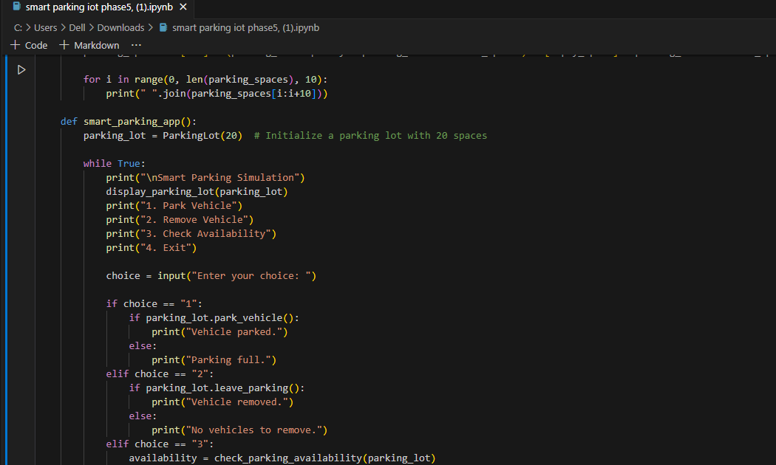

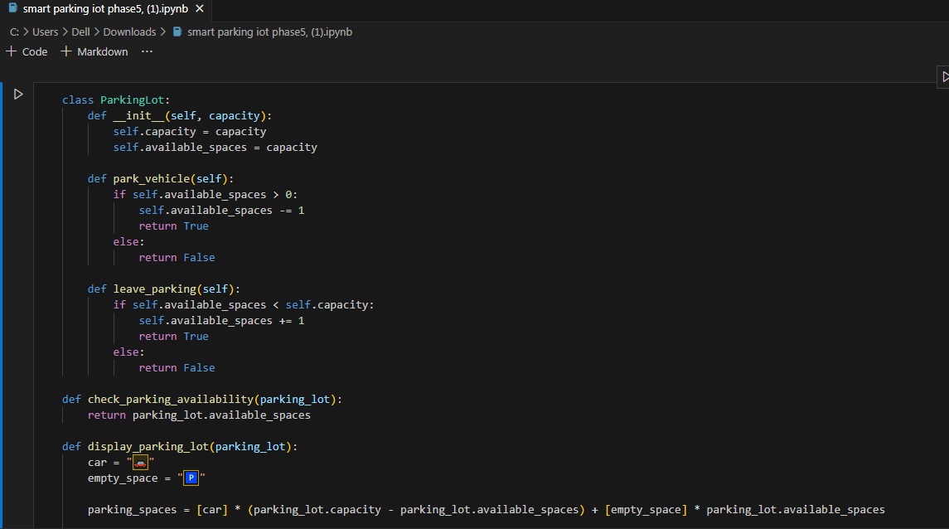

**OUTPUT:**

